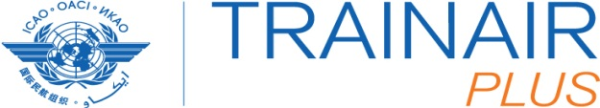
International In
ICAO TRAINAIR PLUS Programme
Training Developers Course (TP TDC)
9 to 20 January 2016
Tehran, Iran
Duration: 2 week Format: classroom Fee: $1,800 USD

REGISTRATION FORM

1. | Name
2. | Position
3. | Organization
4. | Invoice Address
5. | Telephone
6. | E-mail
7. | location of the course
8. | Date of the course
Please take note your registration will only be confirmed once payment has been received.

Please return this form to:

Ismael Faraji
Email: ifaraji@hotmail.com

Please send a copy to:
Trainairplus@icao.int

